

|  |
| --- |
| Android Task |
| Version Number [3.0] |





**Egypt HQ**: A: 94, Street 105, 11431 Maadi, Cairo, Egypt.

**T:** +02 2529 5800 **F:** +02 2529 5888 **E:** [info@linkdev.com](mailto:info@linkdev.com) [www.linkdevelopment.com](http://www.linkdevelopment.com)



# Task Details

## News Feeds App

Create an Android app that contains the following

* 1. Minimum supported version is Android 5.0
  2. Navigation drawer, please check screen below, when clicking on an item, it should show a toast with the section name

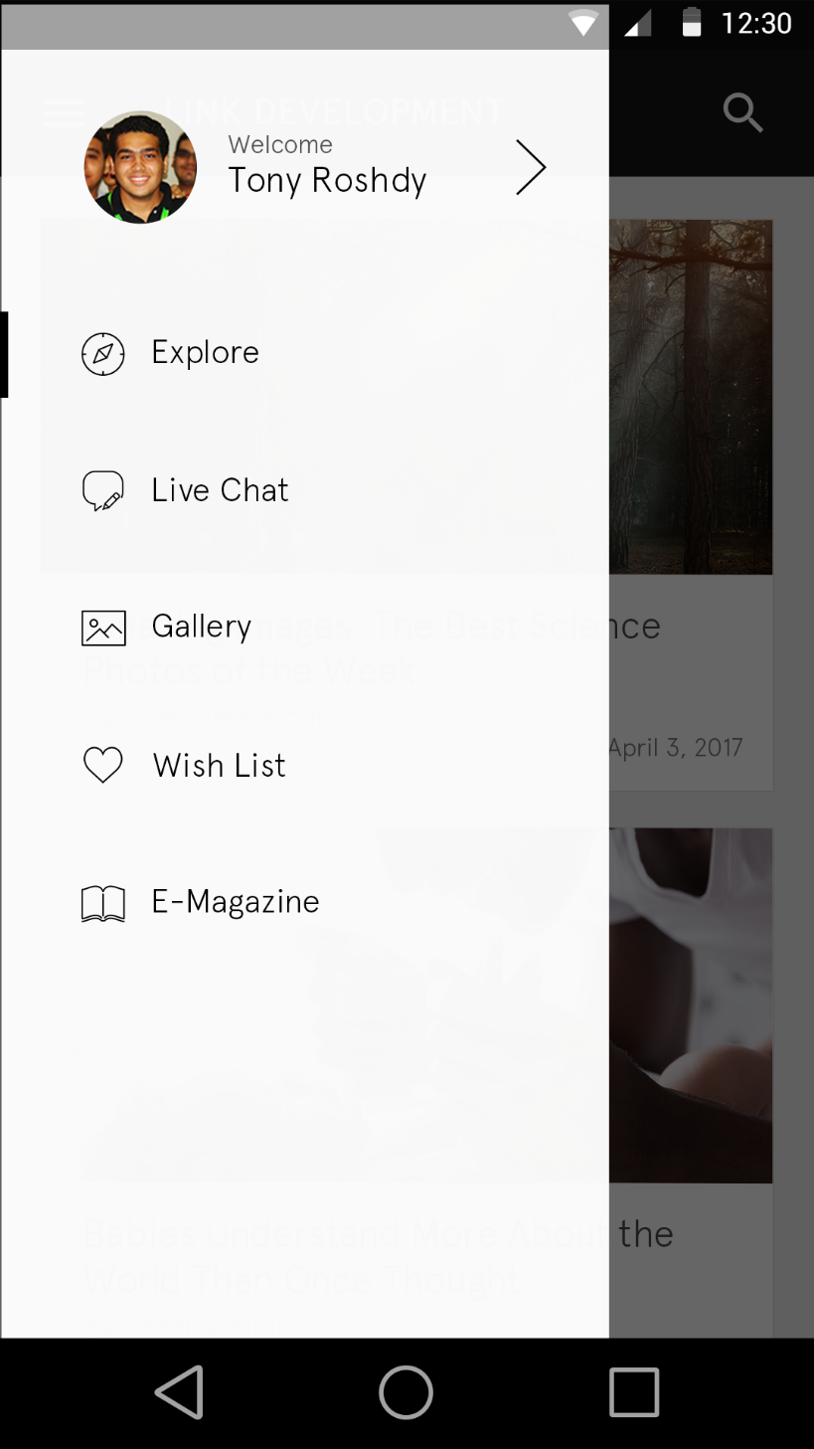

* 1. Home screen contains a list of articles (Check screen below), List of articles displayed in the home screen is a combined list of the returned output from the below two APIs. Call the two APIs and combine the output into a single list to be displayed in the home screen.

<https://newsapi.org/v1/articles?source=the-next-web&apiKey=533af958594143758318137469b41ba9>

<https://newsapi.org/v1/articles?source=associated-press&apiKey=533af958594143758318137469b41ba9>

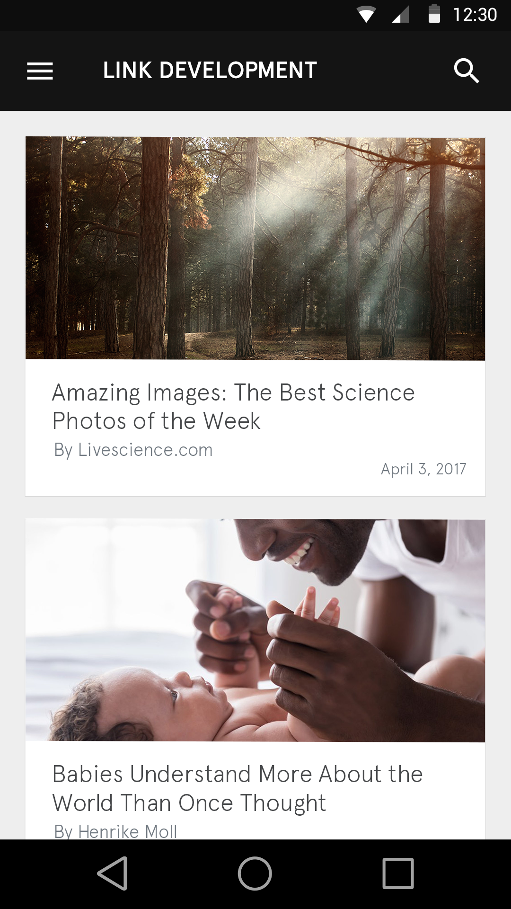

* 1. After selecting an item from the news list user should be directed to the details screen (screen shot below).

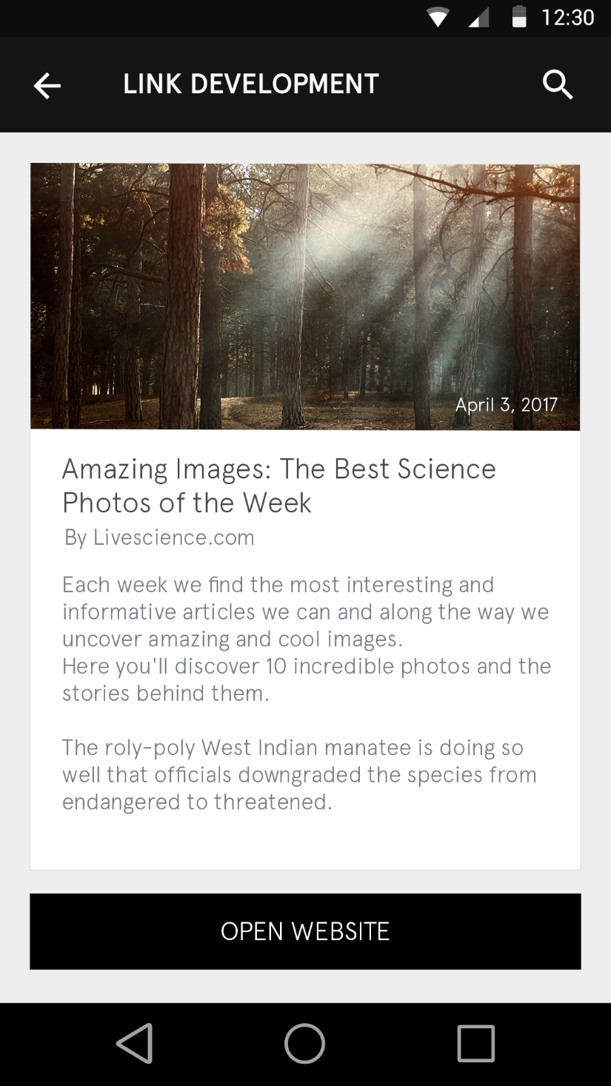

* 1. Upload the source code to a GitHub/BitBucket repository.

You will find all the sliced images you will need in the below folder.

Slicing (<https://linkdevcorp-my.sharepoint.com/:u:/g/personal/nayera_mohamed_linkdev_com/ESEru0h5f7VPh9evwqxqDYgBylIrCYgOgj0oJx_GwV78kg?e=vcmdAe>)